POLYMORPHISM IN CNIDARIA (COELENTERATE)
Coelenterate animals may show a number of zooids. They are of different forms. They take up different functions. These are called polymorphism. This phenomenon is called polymorphism. (Such a colony is called 'Polymorphic' colony). Polymorphism denotes division of labor among the zooids of the individual. Polymorphism is one of the Coelenterate animals characteristics feature .
A polymorphic colony contains many individuals called zooids. They are mainly two types.
1. Medusae
2. Polyps.
Polyp is sedentary. It shows mouth and tentacles at the free end. The medusa is free swarming. Hydra is a Monomoiphic form. It is represented by polyp form. It performs all functions. Obelia like animals Show two forms, polyp nutritive zooid and medusa reproductive zooid. This is called dimorphic organism In a colony of obelia
1) Hydranth (a Polyp stage),
2) Blastostyle (asexually, reproducing zooid).
3) Medusae are present.

POLYMORPHIC TENDENCY IN SIPHONOPHORA ANIMALS
The polymorphic tendency reached its peak in coelenterate organisms belonging to order 'Siphanophora' of class 'Hydrozoa'. Many siphonophora organisms will show complicated structures.
Structure of a typical Siphonophora organism:
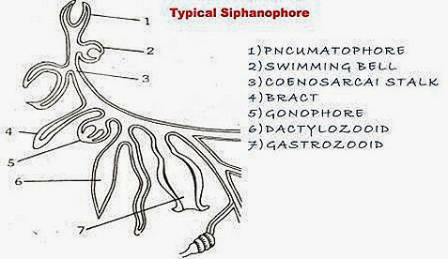
In Hydrozoan coelenterates polymorphic tendency is well developed. The order Siphonophora organisms are exhibiting this tendency to a maximum extent. In a genera bsed siphonophora organism several forms are seen. These forms or zooids are developed from polyps or medusae. These individual zooids are attached to a common stalk called Coenosarc.
POLYPOID ZOOIDS ARE:
1) Gastro zooids
2) Dactylo zooids
3) Gono zooids

MEDUSOID ZOOIDS ARE:
1) Pneumatophore
2) Nectocalyces
3) Bracts
4) Gonophores
1. Gastrozooids : The nutritive polyps are called gastro zooids. They alone take up nutrition in the colony. They are tubular. A mouth is present at the tip of the hypostome. Near the base of a gastrozooid usually a single, long and contractile tentacle arises. It shows batteries of nematocysts. Lateral branches are present called tentilla. Gastrozooids catch the prey and digest it. The digested food is thrown into the coenosarcal canal.
2. Dactylo zooids : They are called Palpons, feelers or tasters. They resemble the gastrozooids. They do not show mouth. Their basal tentacle is unbranched. In Physalia, the tentacle is very long. In velella and Porpita the margin of the colony bears long and hollow tentacles. These zooids are protective in function. They bear batteries of nematocysts.
3. Gonozooids : The reproductive zooids are called gonozooids. They have no mouth. In Physalia the gonozooid shows branched stalk, bearing clusters of gonophores (gonopalpon). Gonozooids produce medusae called gonophores.

MEDUSOID FORMS:
1. Pneumatophores : It functions as a float. It is an inverted medusan
bell. The walls are two layered and highly muscular. The epidermal lining
becomes glandular to form a gas gland. The gas gland secretes gas into the air-sac
1) The pneumatophore is small in Halistemma.
2) The pneumatophore is very large in Physalia.
3) It is disc-shaped in porpita.
2.Nectocalyces : These are swimming-bells. They are medusoid. Mouth, manubrium, tantacles and sense organs are absent. They are helpful in swimming.
3.Bracts : They are also known as hydrophyllia. They are leaf like. In Halistemma a bract covers the zooids of a cormidium.
In Siphonophora many examples can explain polymorphic tendency.
I. Halistemma: This Siphonophora organism will show the greatestpolymorphic tendency. It is a marine organism. It spims in the sea water. It looks-like a single individual. It floats on the top of the sea water. This animal show many kinds of zooids. These are arranged in the coenosarc which is divisible into 2 parts.
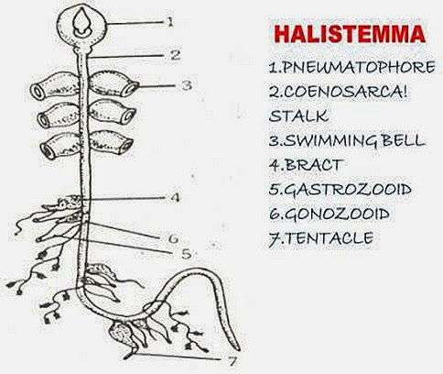
a)Nectosome
b)Siphonosome
a) Nectosome : It is the upper part of the coenosarc. It shows pneumatophores and swimming bells (nectocalyces).
i) Pneumatophores- On the top of the colony a float is present. It is a modified medusoid zooid. It is filled with gas. It is useful to float the cobny on the water.
ii) Swimming bells - Nectocalyces : Below the float a long stalk is present. It is called 'Coenosarcai stalk'. Just below the pneumatophores 3 to5 pairs of swimming bells are present. They are muscular. Because of them the organism swims. These bells are modified Medusae.
b) Siphonosome : The coenosaroal stalk below the swimming bells is siphanosome. On this, groups of zooids will be present called cormidia. Each cormodium includes.
1) Bract 2) Gastrozooid 3) Gonozooids 4) Dactylozooid
1.Bract : It is also called Hydrophillum'. It is a leaf of structure. It will cover other zooids of the cormidium.
2. Gastrozooid : It is a nutritive zooid. It is a modified polyp. It has mouth at its apex. From its base along tentacle will arise. On this tentacle many nematocysts are present. They are helpful in the capturing the prey. The tentacle shows branches called Tentilla'.
3.Gonozooids : It is a reproductive zooid. It produces medusae They take up sexual reproduction.
4. Dactylozooid : It is a modified polyp. It has no mouth. It is a protective zooid. It is defensive in function. At its base a long tentacle is present.
Many such cormidia are arranged on the coenosarcal stalk. Thus Haliste-mma shows the highest degree of polymorphic tendency in Coelenterates.
II. Physalia : It is called Portuguese-Man-of war'. It shows a big float called pneumatophore. Below this pneumatophore stalk is absent. All the zooids are arranged below the float.
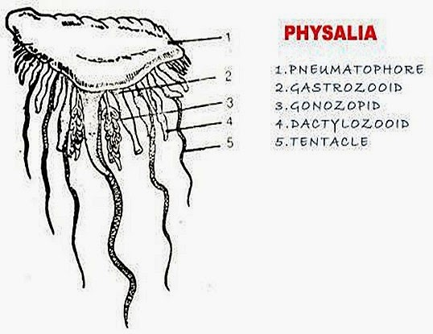

Pneumatophore : It is big and colourful. It is filled with gas. It contains gas glands. They secreate gas. With the help of the float the colony floats on the water.
Gastrozooid: It is a modified polyp. It has a mouth at its tip. It has a long tentacle at its base. The tentacle bears nematocysts. They are helpful in capturing the prey.
Dactylozooid : It is a modified polyp. It has a mouth and tentacle. It bears a number of nematocysts. Dactylozooid is defensive in function.
Gonozooid : They produce medusae which take up sexual reproduction.
III. Porpita : This siphonophore organism will show polymorphic nature. The pneumatophore is large and circular. It contains gas chambers inside.
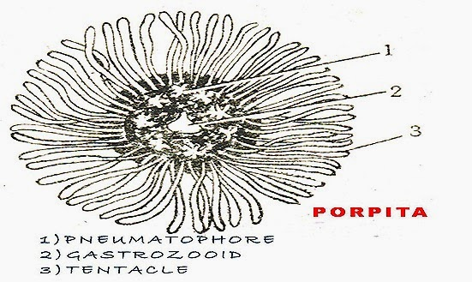
They are separated by partitions. On lower side of the float a big gastrozooid is present. Around the gastrozooid a number of gonozooids are present Gastrozooid is a modified polyp. It has a mouth at its tip. It takes up the function of nutrition.
The gonozooids are useful for reproduction. On the rim or margin of the disc a number of tentaculozooids are present. They are called' Feelers' or Palpons. They are defensive in function. Thus porpita shows polymorphic tendency.

ORIGIN OF POLYMORPHISM:
a) Poly-organ Theory: This is proposed by 'Huxley' and others. According to them the individuals of the colony are the organs of a single medusoid individual i.e., mouth, tentacles, manubrium of the zooid will multiply into different types of zooids and migrate from their original position. Thus a polymorphic individual is formed. According to this theory the polymorphic individual is a single organism.
b) Polyperson theory: Vogt and Gegenbaur proposed this theory. According to them siphonophores are polymorphic colonies of modified polyps which can produce medusae.
Hackel. Balfour agreed the colonial nature of a siphonophore but it was developed from a primitive zooid probably a medusa.
Polymorphism is associated with life history of a coelenterate animal. The asexually reproducing polyp and sexually reproducing medusa will be combined in the form of 'Cluster' and a polymorphic individual is developed.

